PROJECT PLANNING & SCHEDULING

TEAM ID | LTTVIP2026TMIDS69886
PROJECT NAME | Automated car catalog system for enhanced showroom management

Assigned Task to the Group members as shown in below.
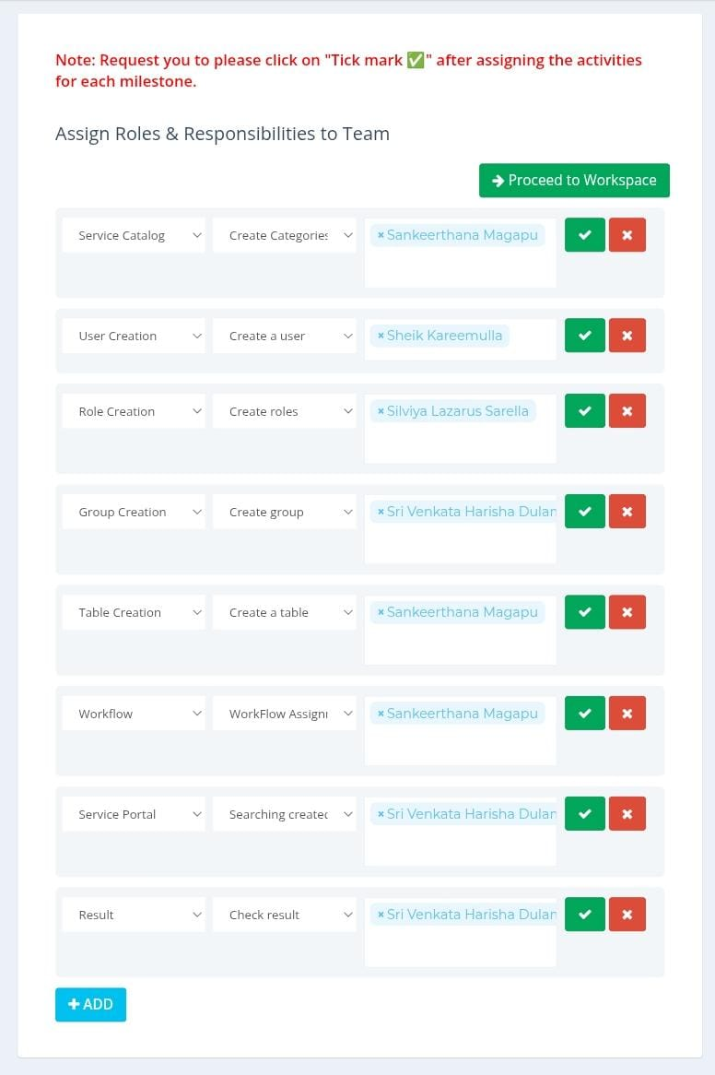

Functional requirement | User story | No of Activi ty | Team Members
Service catalog | As a user, I want to access an automated car catalog through the ServiceNow Service Catalog so that I can easily view, request, and manage available vehicles in the enhanced showroom system. | 1 | Sankeerthana Magapu
User creation | As a showroom manager, I want to automate user creation for the car catalog system in ServiceNow so that new users can quickly access and manage car listings efficiently. | 1 | Sheik Kareemulla
Role creation | As a system administrator, I want to create and assign user roles (e.g., Sales Agent, Inventory Manager, Service Technician) in the automated car catalog system so that each user has appropriate access and permissions for enhanced showroom management inServiceNow. | 1 | Silviya Lazarus Sarella
Group creation | As a showroom manager, I want to create and manage user groups automatically in the Car Catalog System within Service now. | 1 | Sri Venkata Harisha Dulam
Table creation | User Story: As a showroom manager, I want an automated car catalog table in ServiceNow to efficiently manage and track vehicle inventory, features, and availability for enhanced showroom operations. | 1 | Sankeerthana Magapu
Workflow | An automated car catalog system in ServiceNow streamlines enhanced showroom management by enabling seamless vehicle data entry, real-time inventory updates, and automated workflows for approvals, pricing, and customer inquiries. | 1 | Sankeerthana Magapu
Service portal | As a showroom user, I want to access an automated car catalog through the  ServiceNow service portal so that I can easily browse, compare, and request car models for efficient showroom management. | 1 | Sri Venkata Harisha Dulam
Result | A user can automatically view, manage, and update a real-time car catalog in the showroom using ServiceNow, streamlining inventory tracking and customer interactions. | 1 | Sri Venkata Harisha Dulam

